Database :

Login :

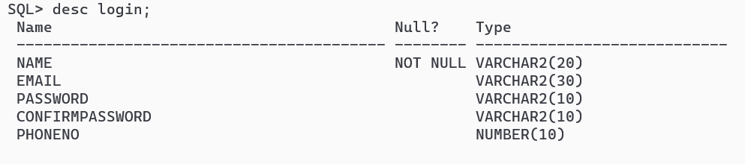

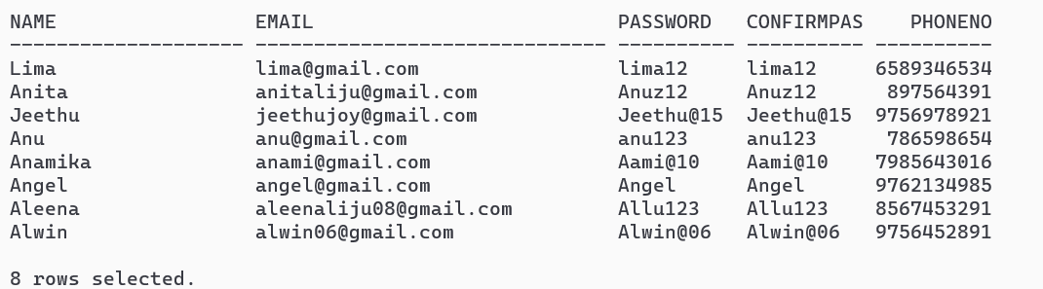

Book;

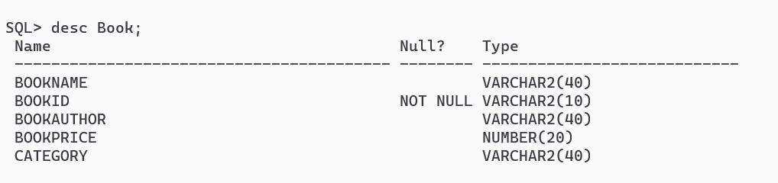

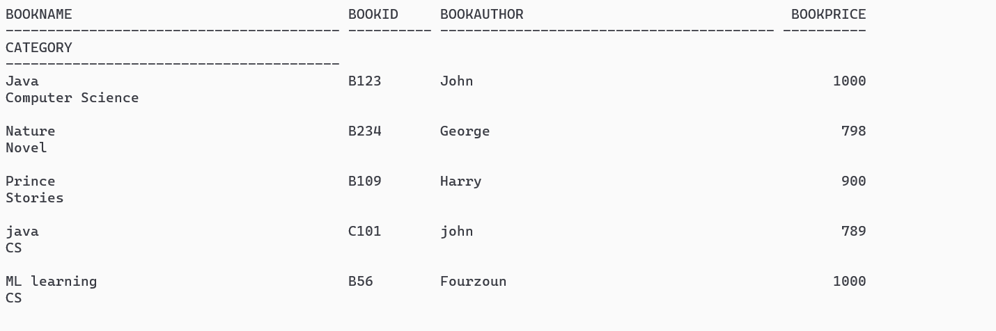

Admin login:

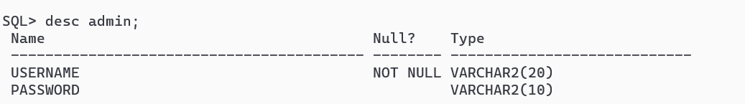

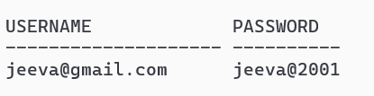

Feedback;

